**Saint Brigid Saint John the Baptist**

16th Sunday in

Ordinary Time

July 22, 2018

**Catholic Church Catholic Church**

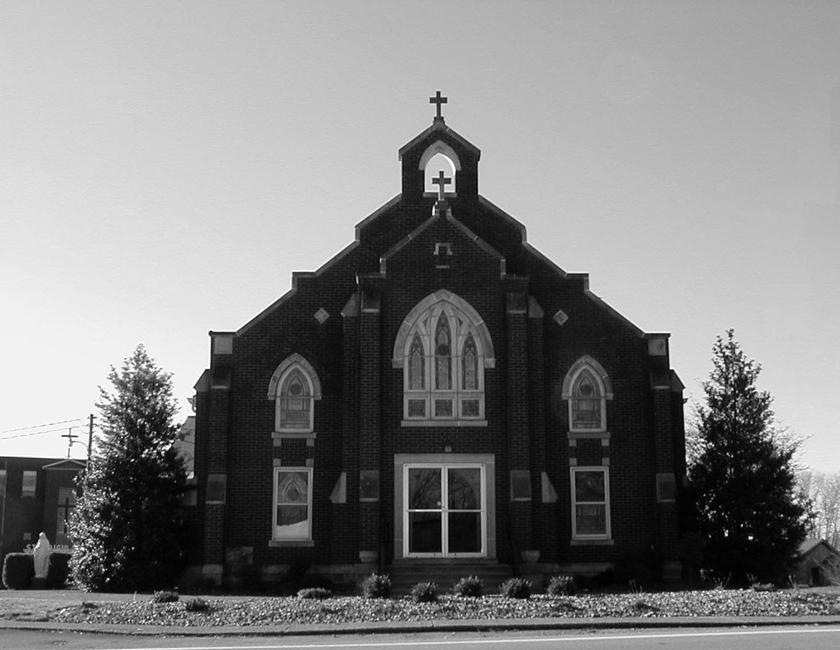

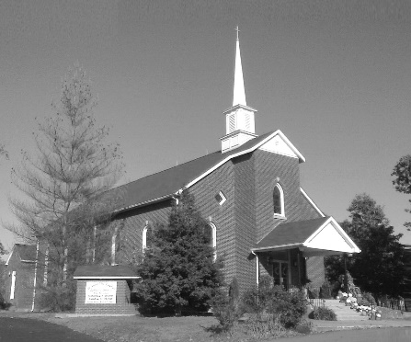

**Pastor:**

***Rev. Daniel L. Lincoln***

Rectory: (270) 877-2546

**Deacon:**

***Michael A. Ryan***

(270) 272-6789

314 E. Main St. 657 St. John Church Rd.

Vine Grove, KY 40175 Elizabethtown, KY 42701

Clustered Parish Office: Clustered Parish Office:

(270) 877-2461 (270) 877-2461

**ANNOINTING OF THE SICK:**

Notify the parish office when a family member is hospitalized.

**BAPTISM:**

Contact the parish office for information about the required preparation class.

**BULLETIN:**

Information must be submitted in writing by note or email to the parish office **no later than 12:00 noon on Wednesdays** for the following weekend. When sending an email, please put “BULLETIN,” and the name of the parish the announcement is for, in the subject line.

**MARRIAGE:**

Contact Father at least 6 months prior to the wedding date to complete required marriage preparations and to schedule the date.

**RCIA (Rite of Christian Initiation of Adults):**

Contact the Worship Chairperson for information.

**DEW MEMORIAL LIBRARY:**

(in St. Brigid Church basement):

Open: Sunday after 9:30 a.m. Mass& 45 minutes before all other Masses.

Email: [brigidvg@bbtel.com](mailto:brigidvg@bbtel.com)

Website: [www.stbrigidvg.org](http://www.stbrigidvg.org)

**Pastoral Associate & Dir. Dir. of Religious Education:**

**of Religious Education:** Lisa Thomas: (270) 735-6930

Deacon Mike Ryan: (270) 877-0546

**Youth Minister: Youth Ministers:**

Lori Law: (270) 723-0157 Angela Churchman:

(270) 268-9963

Ericka Finlay: (502) 612-2644

**MASS SCHEDULE:**

*Sunday:* 9:30 a.m. & 6:30 p.m.

*Monday:* 9:00 a.m.

*Thursday:* 9:00 a.m.

**RECONCILIATION:**

Sunday before Mass

5:30-6:00 p.m. or by appt.

**ROSARY:**

After weekday Masses

**PARISH COUNCIL MEMBERS:**

*President:* Sue Weisshaupt

*Vice-President:* Mike Bramlett

*Secretary:* Judy Cochran

*At-Large Members:* Blake Ryan

& Vincent Thompson

**CHAIRPERSONS:**

*Administration:* Dale Winchester

*Formation:* Tina Yates

*Parish Life:* Tom Billings

*Worship:* Keith Baughman

**MASS SCHEDULE:**

*Saturday (Vigil):*  6:30 p.m.

*Sunday:* 11:30 a.m.

*Wednesday:* 6:30 p.m.

*Friday:* 9:00 a.m.

**RECONCILIATION:**

Saturday before Mass

5:30-6:00p.m. or by appt.

**PARISH COUNCIL MEMBERS:**

*President:* Lauran Thomas

*Secretary:* Theresa Smith

**CHAIRPERSONS:**

*Administration:*  Nick Thomas

*Formation:* Ericka Newton

*Parish Life:* Bradley Wickersham

*Worship:* Greg Thompson



**Mass Schedule**

**Mass Schedule**

|  |  |  |  |  |  |
| --- | --- | --- | --- | --- | --- |
| **Saturday** | **July 21** | **6:30 p.m.** | **St. John** | **For All Parishioners** | **Vigil: 16th Sunday in Ordinary Time** |
| **Sunday** | **July 22** | **9:30 a.m.** | **St. Brigid** | **Dickie Cecil**  **Helen C. “Dicky” Adams** | **16th Sunday in Ordinary Time** |
| **“** | **“** | **11:30 a.m.** | **St. John** | **For Good Health** | **“** |
| **“** | **“** | **6:30 p.m.** | **St. Brigid** | **Our Parish Family**  **Emmett Elmyra Harper &**  **Vic & Bea Whelan** | **“** |
| **Monday** | **July 23** | **9:00 a.m.** | **St. Brigid** | **Irene Jenkins & Joe Stith**  **Rose Marie Yates** | **Weekday** |
| **Wednesday** | **July 25** | **6:30 p.m.** | **St. John** | **In Thanksgiving** | **St. James, Apostle** |
| **Thursday** | **July 26** | **9:00 a.m.** | **St. Brigid** | **Carlos Robbins** | **Sts. Joachim and Anne,**  **Parents of the B.V.M.** |
| **Friday** | **July 27** | **9:00 a.m.** | **St. John** | **For Special Intentions** | **Weekday** |
| **Saturday** | **July 28** | **6:30 p.m.** | **St. John** | **Bruce & Margaret Lincoln** | **Vigil: 17th Sunday in Ordinary Time** |
| **Sunday** | **July 29** | **9:30 a.m.** | **St. Brigid** | **Singer Family - Lawrence, Marie, Bill & Harry and Alice Pfost** | **17th Sunday in Ordinary Time** |
| **“** | **“** | **11:30 a.m.** | **St. John** | **For All Parishioners** | **“** |
| **“** | “ | 6:30 p.m. | **St. Brigid** | **Our Parish Family**  **Sandi Crutcher** | **“** |

**INFORMATION FOR BOTH PARISHES**

**GUIDE BOOK & DIRECTORY ADVERTISING OPPORTUNITY** – We are in the process of updating our annual Guide Book & Directory for our churches. This book will contain everything pertinent to our church: the various ministries, organizations, committees, activities, functions and events plus a complete directory of all members. This book is being provided and direct-mailed to each family at no cost to our church, and it is again being subsidized by local businesses that advertise. If you own or manage a business and would like to find out about advertising in our book, please call the Church Office. Recent survey results by Guide Book Publishing show that 92.1% of families would rather patronize a Guide Book & Directory advertiser over a non-advertiser. It “will pay” to advertise in our new Guide Book & Directory.

**ABORTION AND ADOPTION –** The number of would-be adoptive parents (of newborn babies) far outstrips the supply in America. Each year in the United States, about 135,000 American children are placed for adoption. Experts estimate somewhere between one and two million couples seek to adopt yearly. Every year, there are about 1.3 million abortions. Sadly, only 4% of women with unwanted pregnancies give their children up for adoption. Every child is wanted and wanted desperately! By Pro-Life Articles Author [www.pro-lifearticles.org](http://www.pro-lifearticles.org)

**PROJECT RACHEL** **–** Healing…Forgiveness…Hope…After the experience of an abortion. If you or someone you know is struggling with the pain from an abortion, please consider Project Rachel – a post abortion ministry. To speak to someone confidentially, call (502) 471-2155 or email [ProjectRachel@archlou.org](mailto:ProjectRachel@archlou.org).

**CONFIDENTIAL PREGNANCY AND ADOPTION COUNSELING** – is available at Catholic Charities for women of all ages experiencing untimely pregnancies. A full range of services are provided, including adoptive placement, legal assistance and counseling for individuals, groups and families. Post-abortion counseling is also available. Services are provided regardless of income or marital status. For more information, call Catholic Charities at (502) 637-9786.

**DIVORCED. CATHOLIC. NOW WHAT?** *Journey of Hope* is a unique 15-week divorce recovery ministry program addressing concerns of divorced or separated Catholics. It offers support on important issues that result from divorce. The emphasis on prayer, scripture and the teachings of the Catholic Church lead to healing and a deeper relationship with Jesus Christ. The next 15-week session begins on **Thursday, August 2, from 7:00 to 8:00 p.m.** at St. Joseph Church in Bardstown, KY in the Maloney Room. The cost is $50 which includes all materials, text and workbooks and scholarships are available. Registration forms can be found online at https://www.archlou.org/journeyofhope and further information is available by emailing the Archdiocese of Louisville’s Family Ministries Office at [family@archlou.org](mailto:family@archlou.org) or by calling (502) 349-2922.

**A LINCOLN TRAIL GOLF COURSE BUFFET** – will be held from 11:00 a.m. to 2:00 p.m. the first Sunday of every month. For more information, contact Patty Straney at (270) 268-3336.

**SAVE THE DATE** – Fr. John Judie will have a celebration of his retirement, 70th birthday and 31 years of priestly ministry on **Saturday, August 11, 2018**. More details will follow later. He may be reached at (502) 774-5772.

* * * * * * * * * * * * * * * * * * *

**St. John and St. Brigid Prayer List**

To add someone to the prayer list, please call the parish office at (270) 877-2461. **Remember to call to remove someone from the list if they are no longer sick, etc.** *Please note that the prayer list has been revised. It is primarily for parishioners and their immediate family members*.

Leslie **Adams-Cerniglia**, Sam **Adams**, April **Allen**, Dennis **Arnold**, Barbara **Ashley**, Donnie Alan **Atcher**, Sue **Banks**, Shannon **Barnes,** Denise **Barnett**, Timothy **Birch**, Teresa **Blaycock**, Charlie **Bowers**, Pauline **Brangers**, Ellen **Bryan**, Richard **Bryson**, Carol **Buchanan**, Jeremy & Margie **Buyer**, Deacon Bob **Caspar**, Sue **Caswell**, Ed **Cecil**, J. Mack **Cecil**, Harlan Ford **Clark**, Judy **Cleaver**, John **Connor**, Betty Jo **Cooper**, Heidi **Correa**, Jeff **Craig**, Glynn **Clutches**, Roan **Dowell**, Karen **Dworshak**, Leroy **Embry**, Marion **French**, Martha **Ford**, Dwayne **Garcia**, Carrie **Gribben**, Mary **Hager**, Mrs. Charles **Hair**, Stephanie **Hall**, Donnie **Hart**, Jimmy **Harper**, Bobby **Harris**, Eileen **Heinen**, Debbie **Hodge**, Betty Lou **Jones**, Andrew **Kieta**, Charlene **Langley**, Olivia **Leasor**, Jenny **Leonhardt**, Jackie **Long**, Louise **Lucous**, Alma **Mahanna**, Shelly **Martin**, Shirley **Martin**, Martina **Masoni**, Don **Mattingly**, Gerard **Mattingly**, Paul Michael **Mattingly**, Mary **Medley,** Cindy **Miller**, Starla **Miller**, Doug **Osborne**, Duane **Osborne**, Fr. Stan **Osborne**, Mickey **Padgett**, Frank **Inanely**, Jerry **Phillips**, Annie **Pierce**, Adrianna **Porter**, Jeremy **Porter**, Adrian **Ray**, Allie **Ray**, Mary Agnes **Ray**, Mary Ellen **Ray**, Tonya **Reisinger**, Joel **Rivera**, Pat **Ryan**, Caroline **Seabee**, Ralph **Staples**, Keith **Tassin**, Kenny **Thompson**, Raffaella **Tucker**, Debi **Turner**, Stacey **Vance**, Charlotte **Vowels**, Bill **Waldrop**, Lois **Weaver**, De Neil **Whelan**, Paul A. **Whelan**, Jennifer **Williams**, Sandy **Wiseman**, Zach **Wiseman**, Gail **Wilson**, Don **Wooldridge**, Connor **Wright** and all the sick.

* * * * * * * * * * * * * * * * * * *

**Our Military List**

To add someone to the military list, please call the parish office at (270) 877-2461. **Remember to call to remove someone from the list if they are no longer in the service**.

Lt. Matt **Bednar**, PFC Richard H. **Chapman**, A1C Aaron **Chandler**, A1C Brandon **Davila**, SrA Felicia **Esquivel**, PFC Tyler **Hall**, A1C Ryan **Henley**, A1C Joseph **Manco**, SPC Jacob L. **Nall**, SFC Peter **Novak**, Tony **Rickerl**, James **Rogers**, Tony **Rogers**, Jonathon **Sifford**, Jeffrey **Slade**, Derek **Smith**, CSM Vance **Snider**, Brian **Tomassi**, A1C Daniel **Trombone**, SGT Evan **Vaughan**, PV2 William **Vaughan**, Lisa **Flynn-Veri**, LT Michael **Veri**, LTC Steve **Wickersham**, SGT Clay **Wilson**, TSGT Jeremy **Yates**, Austin **Zulka** and for all who serve and have served our country.

* * * * * * * * * * * * * * * * * * *

**ST. JOHN THE BAPTIST CATHOLIC CHURCH INFORMATION**

**Monthly Budget Amount Needed:** $ 12,500.00

**Monthly Collection for June:**  $ 9,153.00

**Monthly Collection for July:** $ 8,638.00

**WELCOME PACKETS** – If you would like to become a member, or learn more about St. John Parish, please take a *Welcome Packet* in the church lobby. You may return the census card and the stewardship form to Father Dan or place in the collection basket.

**REST IN PEACE** – Please keep Fr. Stan Osborne’s family in your prayers at his death last week. May God’s peace and consolation be with us all.

**UPDATE MEMBERSHIP INFORMATION** – Does our church database have YOUR family membership record correct? Here is your chance to update YOUR record for our annual Guide Book & Directory (if you haven’t already done so). It is time for us to update our database with any changes, additions, or deletions that may have occurred in YOUR family over the past year. Have you changed your phone number? Have you moved? Are you preparing to move soon? Are all of your children still at home and are they all included in your membership record? Do you want your record published? If you have not already informed the Church Office about changes to your record, please let us know now so that the information in the Guide Book & Directory is correct. The Church Office number is (270) 877-2461. *Thank you for your help!*

**VACATION BIBLE SCHOOL** – A big thank you to all that helped make our Vacation Bible School a success.  We had 31 children, 15 youth and 14 adults. We loved singing and learning more about Jesus.  Keep your calendars open next July as we finish our theme of Shipwrecked - Jesus Rescues!

**PARISH COUNCIL MEMBERS** – President – Lauran Thomas; Secretary – Theresa Smith; Administration – Nick Thomas; Formation – Ericka newton; Worship – Greg Thompson and Parish Life – Bradley Wickersham.

**NEW YEAR KICK OFF!** Join us for a pool party/cook out to kick off the beginning of the 2018-2019 Youth Group year! We are extending this invitation to any youth entering 6th-12th grade. We are encouraging those who have never attended youth group to join us as well to see what we're all about! **The pool party will be at Rick and Rhonda Newton's house from 6:00-8:00 p.m. on Thursday, July 26.** Food will be provided - just bring your own towel. Please RSVP to Ericka or Angela by **Tuesday, July 24,** so we have enough food. You can also text/call one of us for the address.

**SAFE ENVIRONMENT TRAINING –** Anyone 18 and older, volunteering in our parish with the RE program, Youth Group, VBS, etc. must attend a Safe Environment Training Seminar sponsored by the Archdiocese.  These are scheduled at various times throughout the Archdiocese. The complete list of available dates can be accessed on the Archdiocese website.  The next scheduled training in our area will be **Thursday,** **August 23, at 6:30 p.m. at St. James Church, Batcheldor Hall in Elizabethtown.** Any questions regarding this training please contact Lisa Thomas  (270) 735-6930 or [glalt@comcast.net](mailto:glalt@comcast.net).  If you attend this training, please be sure to return your completed form to Lisa Thomas.

* * * * * * * * * * * * * * * * * * *

**St. John Liturgical Ministers**

|  |  |
| --- | --- |
| **Vigil: 17th Sunday in Ordinary Time, July 28, 2018, 6:30 p.m.** |  |
| Extraordinary Ministers of the Eucharist | Abby Newton Rhonda Newton Becky Thomas |
| Lector | Abby Newton |
| Servers | Volunteers |
| Greeter(s) | Hannah Thomas |
| Gift Bearers | Marcella Crewz Barbara Givan |
| - Ushers | John Thomas Kenny Heibert |
| **17th Sunday in Ordinary Time, July 29, 2018, 11:30 a.m.** |  |
| Extraordinary Ministers of the Eucharist | Tracie Price Raeburn Mattingly Linda Thomas |
| Lector | Richard Goode |
| Servers | Caia Goode Faith Ramos |
| Greeter(s) | Tracie Price |
| Gift Bearers | Martha Thomas Family |
| Ushers | Kevin Thomas David Pike |
| **Hospital Ministry – Sunday, July 22, 2018** | Marcella Brangers |

**ST. BRIGID CATHOLIC CHURCH NFORMATION**

**Monthly Budget Amount Needed:** $ 25,280.00

**Monthly Collection for June:** $ 21,488.83

**Monthly Collection for July:** $ 24,350.00

**WELCOME VISITORS** – If you are interested in joining our parish, please pick up a Welcome Packet at the church doors. Complete the registration form and either drop it in the collection basket or mail it to the office. If you just need to update your registration, there are also forms available.

**THANKS!!** to Nan Filburn and Linda Rogers who operate our St. Brigid St. Vincent de Paul Society.

**UPDATE MEMBERSHIP INFORMATION** – Does our church database have YOUR family membership record correct? Here is your chance to update YOUR record for our annual Guide Book & Directory (if you haven’t already done so). It is time for us to update our database with any changes, additions, or deletions that may have occurred in YOUR family over the past year. Have you changed your phone number? Have you moved? Are you preparing to move soon? Are all of your children still at home and are they all included in your membership record? Do you want your record published? If you have not already informed the Church Office about changes to your record, please let us know now so that the information in the Guide Book & Directory is correct. The Church Office number is (270) 877-2461. *Thank you for your help!*

**PARISH COUNCIL** – 2018-19 members are President - Sue Weisshaupt, Vice-President – Mike Bramlett, Secretary – Judy Cochran, At-Large Members – Blake Ryan & Vince Thompson.

**BASKETBALL PROGRAM** – Basketball will not begin until October, so we will post sign-up sheets in August. So far, we have had one adult offer to coach and one adult offer to coach and play in an adult league.

**POT LUCK CELEBRATION** – Join us on **Sunday, August 5, at 4:00 p.m.** as we dedicate our newly renovated school cafeteria. Everyone, who wants one, receives a free copy of the newly published *St. Brigid School Memories* book!

**BLOOD DRIVE** – The next drive will be held on **Friday, August 10,** **from 10:00 a.m. to 2:00 p.m.** in the CCC building. Give the gift of life!! This is more rewarding than what else you have to do today.

**SUMMER EVENT TICKET SALES** – We have sold 54 tickets so far. We have 246 tickets left. We have 55 days until September 16, 2018 Summer Event. We need to sell 4.7 tickets per day to sell all the summer event tickets.

**SUMMER EVENT** – The Summer Event is fast approaching, Sunday, September 16 from 1:00-4:00 p.m.  THIS IS OUR ONLY FUND RAISER FOR ST. BRIGID AND WE NEED ALL TO PARTICIPATE TO MAKE IT A GREAT SUCCESS. It provides for many renovation projects.  We are selling 300 tickets to win a $10,000 Capital Prize.  The odds are tremendous and has been won by a parishioner every year.  The tickets are $100 each, but you can split the cost with a group.  Two dinner tickets come with each ticket purchased.   We'll have Silent Auction items, live music, bounce houses, and other activities for kids of all ages.  The Summer Event Ticket Order Forms are at the side doors of the church and the table in the back of church.  A committee member will be available after each Mass to assist in your purchase.  We also need volunteers to help.  **GET INVOLVED!** Should anyone need additional information, please contact Teresa Morgan (270) 862-2909; Gina Ryan (270) 735-6355 or Deacon Mike Ryan (270) 877-0546 or (270) 272-6789.

**QUILT RAFFLE** –This year’s quilt is a blue flower pattern. The quilt is on display at the main doors of the church. We have quilt tickets for sale at $1.00 each.



**COMMUNION MINISTER UPDATE SESSIONS** – are for those ministers needing a mandate renewal, who have already completed the archdiocesan two-session Communion Minister Formation Program. This session will fulfill the requirements for continuing formation for Extraordinary Ministers of Holy Communion. I have scheduled the mandatory update session for **September 27, 2018 from 7:00- 9:00 p.m.** Please add to your calendar. I will put the form applications out three weeks before and make sure a new announcement gets into the bulletin. Should you have questions please contact Deacon Mike.

* * * * * * * * * * * * * * * * * * *

**St. Brigid Youth Ministry**

**Wednesday, August 1** – Youth Open Gym in the CCC for all 8th-12th grades from 6:30-8:30 p.m. Join other youth for an evening of fellowship and fun.

**Wednesday, August 8** – Back to School Bash! Our normal open gym in the CCC from 6:30-8:30 p.m. for all 8th-12th graders, but we will celebrate the start of school with Subway, games and prizes.

**Friday, August 10** – Back to School Lock-In. Permission forms are in the packets or call Lori.

**Sunday, August 12** – Back to School Kart Kountry Outing for high schoolers & their families. This takes the place of the River Bats game that was cancelled due to lack of interest. Permission forms and info coming soon.

If you have any questions, please contact Lori at (270) 723-0157 or email at [stbrigidyouth@hotmail.com](mailto:stbrigidyouth@hotmail.com).

**St. Brigid Monthly Meet and Greet**

St. Brigid Parish hosts a “Meet and Greet” downstairs the 2nd Sunday of each month immediately following the 9:30 a.m. Mass with coffee and donuts. This is a great opportunity for existing parishioners to extend a warm welcome to visitors and anyone interested in joining St. Brigid Parish. Be sure to also visit the Dew Memorial Library. **The next Meet and Greet will be Sunday, August 12, 2018.**

**St. Brigid Liturgical Ministers**

|  |  |
| --- | --- |
| **17th Sunday in Ordinary Time, July 29, 2018, 9:30 a.m.** |  |
| Extraordinary Ministers of the Eucharist P. | Helen Hicks Jim Klimesh |
| C. | Bill & Rosie Cochran Sherleen Barren Patty Sims |
| Lector | David Stoddard |
| Servers | Cal Yates Tylar Craig |
| Greeters | Terrie Morgan David & Paula Stoddard |
| **17th Sunday in Ordinary Time, July 29, 2018, 6:30 p.m.** |  |
| Extraordinary Ministers of the Eucharist P. | Ron Masoni |
| C. | Ken Spangenberger Jim Weed |
| Lector | Kathleen Bramlett |
| Servers | Christopher Morgan Nathaniel Morgan |
| Greeters | Volunteers |
| **Hospital Ministry – Sunday, August 12, 2018** | Ralph & Sherleen Barren |

**ST. VINCENT DE PAUL SOCIETY**

St. Brigid and St. Christopher Conference

July 1, 2017 – June 30, 2018

Beginning Balance $16,198.00

INCOME:

Church Collections $19,868.00

Interest Income $ 33.00

TOTAL INCOME $19,901.00

EXPENSES:

Families Served $18,337.00

Dues to Louisville Council $ 350.00

TOTAL EXPENSES: $18,687.00

ENDING BALANCE: $17,412.00

Total People Helped 535

Volunteer Hours 262

Miles Driven 3,050

* * * * * * * * * * * * * * * * * * * * * * * * * * * * * * * * *

You have been so generous and faithful to this cause.

Thank you for caring and reaching out to those in need!